Graph‑Driven and Knowledge‑Driven Enhancements to RAG: A Multi‑Paradigm Comparative Framework

Zensar Technologies, Pune, India
n.mouna@zensar.com

Corresponding Author: Mouna Nataraja armouwin@gmail.com

Abstract. Retrieval-Augmented Generation (RAG) has become a popular approach to improving the factuality of generation by language models by grounding generated responses on external knowledge sources. However, most existing RAG systems are based on unstructured text retrieval limiting their capacity to maintain relational structure, and support multi-step reasoning and provide interpretable evidence for generated outputs. To overcome these limitations, there have been recent efforts to consider the integration of knowledge graphs into RAG pipelines, resulting in the development of Knowledge Graph-Enhanced Retrieval-Augmented Generation (KG-RAG) and Graph RAG systems, with more and more attention being directed to graph-based reasoning functions.

This work has presented such a structured study with a primary focus on comparing RAG and Graph RAG paradigms which are traditional, and KG-RAG is an intermediate evolution. The results show that while vanilla RAG works well for direct and fact-based queries, it has its limitations when it comes to queries that need to be relationally understood. KG-RAG enhances this contextual grounding by adding relationships at the entity level, while Graph RAG gives further power to this paradigm by adding multi-hop reasoning, that is the capacity to reason explicitly by traversing the graph. Experimental results show that Graph RAG is always able to generate better coherent and contextual-based responses for complicated queries involving inter-entity dependencies. In addition, it allows for clearer reasoning traceability by focusing outputs along identifiable paths to the relations which in turns increases it's interpretability and validation.

Observations stemming from the evaluation have taken part: Graph RAG offers a stronger framework for processing complex, relationship-driven queries, relative to traditional RAG, as well as a corresponding promiscuous complex pattern of the system. Overall, this work captures the architectural evolution from the unstructured retrieval to the graph-based reasoning and offers a concentrated comparative analysis about capabilities, trade-offs and applicability of these in practical applications.

Keywords: Knowledge Graphs, Retrieval-Augmented Generation (RAG), GraphRAG, Large Language Models (LLMs), Multi-hop Reasoning, Comparative Analysis

Introduction

1.1 Background and Motivation

Large language models have rapidly emerged as a central component of intelligent systems of the modern era that is driven by the ability to generate fluent and contextual natural language in a broad range of different contexts. In spite of these developments, a basic constraint in the representation of such models of knowledge still remains untouched. The information used during generation is implicitly encoded in model parameters during pretraining and thus static knowledge that cannot be reliably updated and verified during inference. This limitation presents as well-documented problems such as hallucination, fact inconsistency and being sensitive to domain shift [5,19] .

Such issues are particularly troublesome in knowledge-intensive and high-stake fields, including scientific research, healthcare, manufacturing and enterprise decision support. The generated outputs in these settings are expected to be accurate and traceable by verifiable sources.

RAG was suggested as a practical means of overcoming these shortcomings. Retrieval-Augmented Generation (RAG) has been officially introduced as outlined by [10] as the combination of dense retrieval with sequence-to-sequence generation on knowledge-intensive NLP tasks. RAG particularly reduces the reliance on parametric memory and enables the systems to consider updating and accessing the domain-specific knowledge using information external to the system during the inference and conditioning generation based on this evidence [10].

1.2 From Retrieval-Augmented Generation to Structured Grounding

Conventional RAG systems have been based mainly on the retrieval of unstructured text using dense embeddings and similarity search. While good for matching surface-level document/sequence relevance, this way of processing retrieved documents or passages as stand-alone pieces of text. As a result, relational semantics like how entities are connected, how facts are dependent on one another or how the evidence should be combined with each other, etc. are implicit and need to be deduced by the language model itself [2].
This explicit deficiency, has been empirically demonstrated to inhibit the ability of vanilla RAG systems to aid multi-hop reasoning, causal inference and complex query solution. Retrieved contexts can be redundant, vaguely related, or internally inconsistent that further enhances the cognitive load on the generator as well as adds to residual hallucination [15].

These findings have led to the study of retrieval processes which are not responsive to some single task such as, say, flat text similarity, but instead consider structured representations of knowledge. In this context, knowledge graphs have become a natural choice to be combined with retrieval to boost it, because they explicitly encode entities, relationships, and semantic constraints that are important when it comes to reasoning-intensive tasks [4].

1.3 Knowledge Graph–Enhanced Retrieval-Augmented Generation

Knowledge Graph-Augmented Generation (KG-RAG) is commonly seen as a family of architectures which embody knowledge graphs into the retrieval and grounding components of RAG systems. Rather than using unstructured document sources, KG-RAG systems would instead focus on structured representations instead, and use such representations to guide evidence selection, as well as uphold relational context and enable interpretable rationale [2,6].

In KG-RAG, knowledge graphs can either be used to find relevant entities, navigate relational pathways, extract coherent subgraphs or to re-rank retrieved evidence based on their structural relevance. These mechanisms allow retrieval to reflect not only similar semantics, but logic and relations with the query. As a result, KG-RAG systems strive to help counter the issues of hallucination, faithfulness and give clearer grounding to the generated outputs.

Notably, KG-RAG is not a replacement of language models and retrieval-based grounding but, instead, it is an extension to them with structured reasoning abilities. This placement contrasts KG-RAG with purely symbolic systems, or end-to-end generative systems and places it in the context of being one of the evolutions of the architecture in the broader RAG paradigm [5].

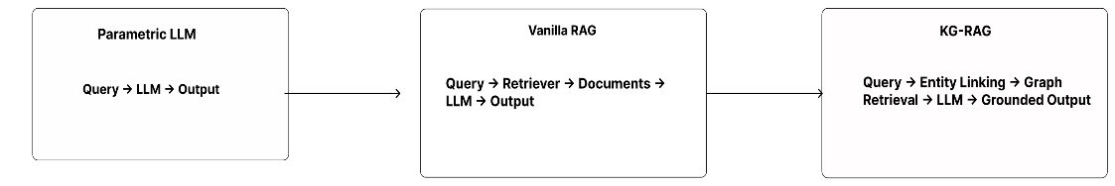
Figure 1. Conceptual evolution from parametric language models to retrieval-augmented generation and knowledge graph–enhanced retrieval-augmented generation.

The advancement of the parametric language models into vanilla retrieval-augmented generation and then to Knowledge Graph-Enhanced Retrieval-Augmented Generation indicates growing amounts of external grounding and structural consciousness, as shown in Figure 1. While parametric models rely solely on internally encoded knowledge, RAG introduces document-level textual grounding through external retrieval. KG-RAG further extends this paradigm by incorporating explicit entity and relational structure into the retrieval process, thereby enabling more precise grounding and relational reasoning.

1.4 Scope

Knowledge Graph-exploration Knowledge Graph-enhanced Retrieval-Augmented Generation ( KG-RAG ) is a line of architectures that incorporate knowledge graphs to the retrieval and the grounding steps of RAG architectures. Rather than just using unstructured document-based representations, KG-RAG systems make use of structured representations to inform the process of evidence selecting, maintain the relational context of the facts, and provide interpretive reasoning [15,19].

In KG-RAG, knowledge graphs can either be used to find relevant entities, navigate relational pathways, extract coherent subgraphs or to re-rank retrieved evidence based on their structural relevance. These mechanisms allow retrieval to reflect not only similar semantics, but logic and relations with the query. As a result, KG-RAG systems strive to help counter the issues of hallucination, faithfulness and give clearer grounding to the generated outputs [7,12,15].

- Foundations of Retrieval-Augmented Generation

2.1 Motivation for Retrieval-Augmented Generation
The need and the motivation behind the development of Retrieval-Augmented Generation were mainly the realization that large language models, with all their ability to express themselves, are lacked explicit expression of knowledge and cannot dynamically update that knowledge. The information utilized during the generation process is implicitly encoded in model parameters during the pretraining process, which has limited the model's capacity to adapt to new facts, domain-specific knowledge, or changing conditions in the real world. This architectural constraint has been found time and again as one of the main causes of hallucinations and factual inconsistency in generative mechanisms [5].

In many practical applications, especially where technical, scientific, or regulatory knowledge is involved, the users expect generated responses to be based 'e.g.' on verifiable sources, rather than on inferred responses based only on statistical patterns. Purely parametric generation has a difficult time meeting this expectation, since it is not possible to reliably trace the provenance of generated content. Retrieval-Augmented Generation solves this limitation by adding an external access mechanism for knowledge at inference time, enabling the system to consider explicit evidence as part of the generation process [10].

By ensuring storage of knowledge outside of the language model, RAG allows systems to be flexible and up to date without retraining. This separation of concerns has led RAG to become a key paradigm of knowledge-intensive tasks, in which it is as important that the results are considered accurate and transparent as it is that they are linguistically fluent [11].

2.2 Canonical RAG Architecture

The canonical architecture of a RAG system consists of two parts: a retriever and a generator. This two-part architecture is based on the formulation introduced; dense retrieval is closely integrated with a sequence-to-sequence generator [10]. The retriever is a query by the user expressed as a dense vector, and searches within a large collection of documents/passages that have been embedded identically. Similarity-based measures (like cosine similarity or inner product) are frequently used to perform retrieval in large scale vector indices, enabling efficient retrieval.
The passages that have been ranked top are then passed to the input context of the generator. The language model produces an output whereby the query and the evidence retrieved is formally conditioned together. This design allows to base its responses on external information.
There are practical benefits of this architecture. Retrieval and generation can be developed and optimized independently, knowledge sources can be updated without changing the model, and different language models can be reused in multiple domains by changing the retrieval corpus. These properties have helped to make RAG a popular baseline architecture in the research and production systems alike [15].

2.3 Implications for Structured Knowledge Integration

The weakness of vanilla RAG gives way to broader insight, the use of external knowledge as a basis of the generation process is only valid when the retrieved knowledge is systematized in a manner that it can be utilized to reason. Unstructured text is very descriptive but does not include explicit descriptions of entities, relationships, and constraints. Consequently, relational semantics are left implicit and must be re-built heuristically in the generation.

These findings have inspired further studies on organized retrieval substrates that can inform evidence selection in a more explicit manner. The knowledge graph, formalizes nodes, entities and the relationship among them in an interpretable and formal way, provides a natural extension of the RAG paradigm. With the addition of graph-based representations to retrieval, systems can transition the similarity at the surface to reasoning-conscious grounding, establishing the conceptual basis of Knowledge Graph enhanced Retrieval augmented Generation [4,19].

3. Architectures of Knowledge Graph–Enhanced Retrieval-Augmented Generation

Architectures for Knowledge Graph-Enhanced Retrieval-Augmented Generation (KG- RAG) could be seen as an evolutionary enhancement of the traditional Retrieval-Augmented Generation (RAG) pipeline enacted by the need to encode explicit structural cues in the retrieval part of a pipeline. While the traditional RAG architectures seek to retrieve unstructured text based on semantic similarity, KG-RAG systems seek to retrieve evidence denoting relational semantics encoded in knowledge graphs.
Most KG- RAG architectures maintain a modular separation between the retrieval and generation. The language model does not change, but to guide the selection and organization of evidence, some mechanisms that are aware of the graph are added upstream. This design choice is motivated by practical considerations as this enables using existing pretrained models while improving retrieval quality using structured reasoning. Consequently, KG - RAG systems are usually characterized by richer retrieval pipelines instead of more complex generators.
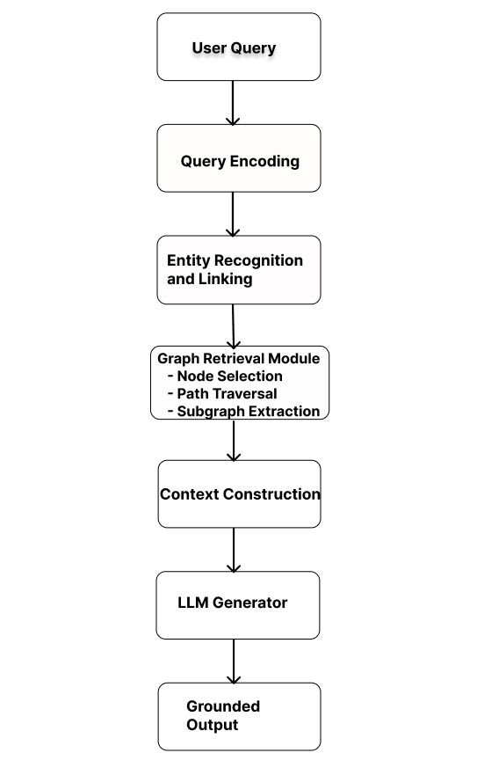
Figure 2. Canonical architecture of Knowledge Graph–Enhanced Retrieval-Augmented Generation, illustrating modular separation between graph-aware retrieval and neural generation components.
As shown in Figure 2, KG - RAG architectures preserve the modular separation between retrieval and generation with the addition of structured reasoning abilities in the retrieval stage. Following the encoding of queries and the recognition of entities, mechanisms graph-aware retrieval to node selection, relational traversal and subgraph extraction are performed, where a structured evidence context is built. This context is then fed to the language model generator which generates grounded outputs. The architecture focuses on structured retrieval as opposed to modifications to the generative backbone and this is consistent with the secondary nature of the modular design philosophy in systems surveyed.

Table 1. Architectural taxonomy of Knowledge Graph–Enhanced Retrieval-Augmented Generation systems, categorized by retrieval substrate and structural integration strategy.

Architecture Type | Core Retrieval Mechanism | Structural Role of KG | Strengths | Limitations
Hybrid Text–Graph | Dense retrieval + graph expansion | Post-retrieval relational enrichment | Scalable, balanced reasoning depth | Entity linking sensitivity
Graph-Centric | Direct subgraph/path retrieval | Primary retrieval substrate | Strong interpretability, multi-hop reasoning | Computational overhead
GNN-Based | Subgraph encoding via GNN | Learned structural abstraction | Rich relevance modeling | Reduced transparency
Modular Enterprise-Oriented | Decoupled graph + retrieval modules | Domain-specific reasoning layer | High explainability, industrial applicability | Engineering complexity

Table 1. provides an overview of some of the main knowledge graph (KG)-integrated retrieval architectures. These architectures vary mainly in the structure of the KG incorporation into the retrieval pipeline and the extent of this influence on the retrieval process.Each architecture has its own unique tradeoffs of the capability to reason, interpretation, scalability, and complexity of systems.

4. Retrieval Strategies in Knowledge Graph–Enhanced Retrieval-Augmented Generation

The integration of knowledge graphs in retrieval-augmented generation does not create a monolithic architecture but rather sparks the creation of graph-aware retrieval strategies with granularity, structural depth and reasoning capability as their metrics. While previous sections looked respectively at patterns of architectural integration, there is an explicit focus on the operationalisation of knowledge graphs in the retrieval phase. This distinction is relevant: architectural design defines the overall system structure, and retrieval strategy controls that of selection, traversal, filtering, and preparation of structured knowledge for generation processes behind.

In the context of conventional RAG system, retrieval is typically casted as a similarity search problem over unstructured textual corpora. By contrast, KG-RAG systems reconceptuali retrieval as a rationalised reasoning process over entities and their inter-relations. This change allows for the use of different approaches, from localised entity neighbourhood growth to graph relational path extraction and graph-level denoising. Each strategy represents different assumptions about the definition of relevant evidence and how relational semantics should be used in grounding.

Importantly, these strategies should not be interpreted as mutually exclusive or necessarily sequential stages. Many KG-RAG systems combine several retrieval paradigms in its hybrid retrieval pipelines and in turn ensure a compromise between the aspects of scalability, interpretability and depth of reasoning [6,19]. For example, entity-centric anchoring may be followed by relation-aware filtering, path-based reasoning or subgraph extraction, depending on the complexity of the tasks and the structure of the domains. Consequently, the selection of the retrieval strategy is often determined by application-specific constraints, rather than a fixed theoretical hierarchy.

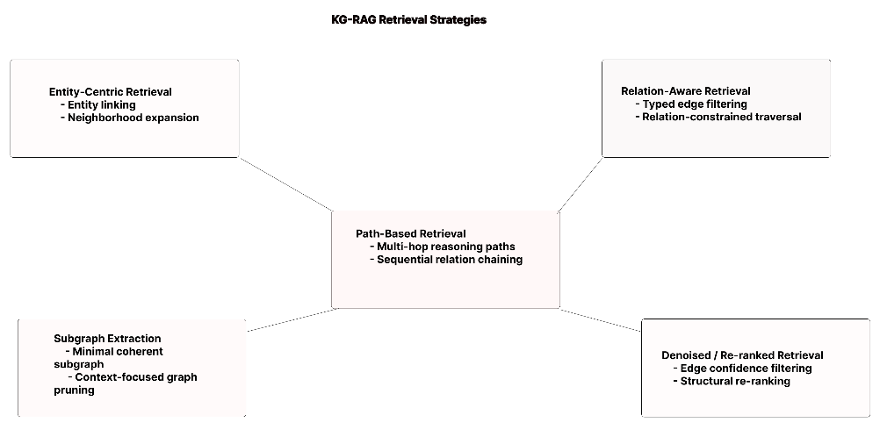Figure 3. Progressive spectrum of graph-aware retrieval strategies in Knowledge Graph–Enhanced Retrieval-Augmented Generation, illustrating increasing structural reasoning depth from entity-centric expansion to denoised and re-ranked subgraph retrieval.

Table 2. presents a comparative analysis of graph-based retrieval strategies in knowledge graph–enhanced retrieval-augmented generation (KG-RAG) systems.

Retrieval Strategy | Unit of Retrieval | Supports Multi-Hop Reasoning | Noise Sensitivity | Hallucination Mitigation Potential
Entity-Centric | Node neighborhoods | Moderate | Medium | Moderate
Relation-Aware | Typed edges and relations | High | Medium–High | High (structure-aligned filtering)
Path-Based | Multi-edge reasoning paths | Very High | High (path explosion risk) | High (explicit reasoning chains)
Subgraph Extraction | Minimal coherent subgraphs | High | Medium | High (context coherence)
Denoised Retrieval | Confidence-filtered graph elements | Strategy-dependent | Low | Very High (reduced spurious links)

Table 2. shows a comparative analysis of graph-based retrieval strategies in knowledge graph enhanced retrieval-augmented generation systems. These strategies vary in the granularity of retrieval, based on single entities, relation triples, complex paths and subgraphs. While entity-centric and relation-aware approaches have simplicity and efficiency, they bring less support for the situation of deep multi-hop reasoning. Overall, there is a trade-off when it comes to choosing which retrieval strategy to use; its depth of reasoning, reliability, and computational complexity.

5. Experimentation

The experimental evaluation is made using a synthetic finance dataset created to simulate real world inter-organizational relationships. The knowledge graph is assembled using a rich synthetic real-world financial data set of 10 firms in different industry segments including manufacturing, technology, software-as-a-service and diversified conglomerates. The data set contains more than 200 financial documents and disclosures, including revenue records and financial reports, balance sheets, acquisition statistics, and operational metrics.

The structured knowledge graph contains over 150 semantically typed relationships describing important financial interactions such as acquisitions, equity and debt instruments, partnerships, supply chain dependencies, and performance indicators such as return on equity (ROE), return on assets (ROA) and debt/to-equity ratios. Entities within the graph represent things like firms, financial metrics, securities, and operations like employee numbers, facilities, and customers.

For the Vanilla RAG setup, the dataset is used in its unstructured document form allowing semantic retrieval over the textual data. In contrast, KG-RAG and Graph RAG make use of the entity-centric structured graph representation to facilitate entity-centric retrieval and multi-hop reasoning. And this unified data set structure facilitates a thorough assessment of the retrieval, reason, and interpretability of different RAG paradigms.

6 Experimental Approaches

6.1 Vanilla RAG

The baseline system is based on a traditional Retrieval-Augmented Generation pipeline where the queries are processed through embedding-based semantic retrieval over the unstructured documents. Retrieved documents are then introduced to the language model and answered.
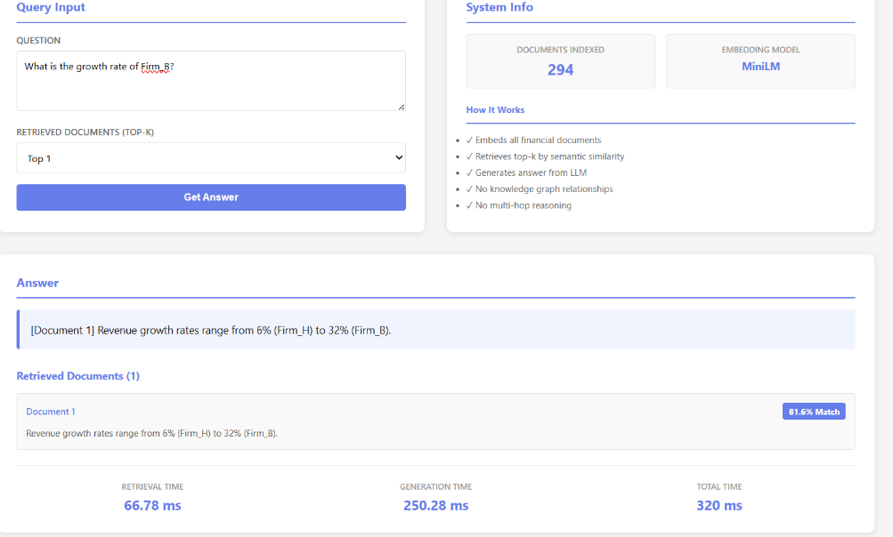
Figure 4. Traditional RAG interface showing semantic retrieval without graph-based reasoning.

As shown in figure 4. , this approach works well if the query is direct and facts-based, it does not have an awareness of what is related to what. As a result, it has difficulties in making queries in which we need to combine information across multiple entities or to reason over dependencies.

6.2 Knowledge Graph Enhanced RAG (KG-RAG)

The KG-RAG system takes structured knowledge into account and models entities and relations in graph form. Query processing is the process of extracting a local subgraph around the entity of interest.

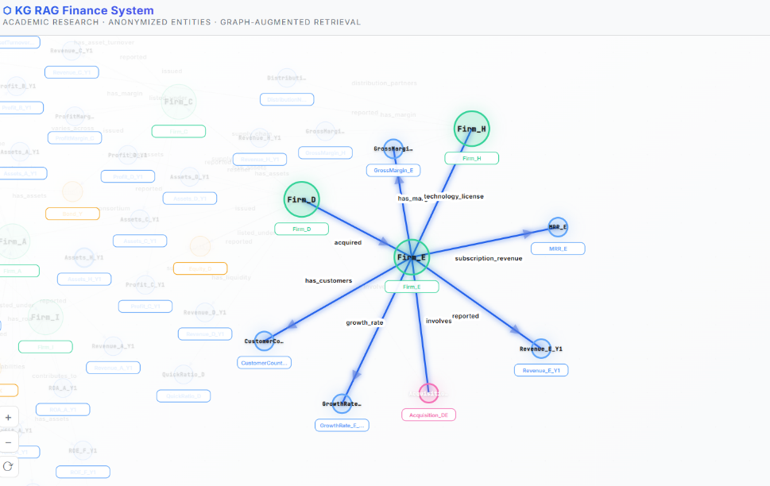
Figure.5. KG-RAG visualization showing entity-centric retrieval with structured relationships between firms, financial metrics, and event.

As shown in Fig.5, the system extracts information specific to the entity and linked directly connected nodes such as financial metrics and other related firms. This helps in better contextual grounding and allows the system to maintain relational information. However, the reasoning ability is still reduced to immediate or shallow relationships in the graph.

6.3 Graph RAG

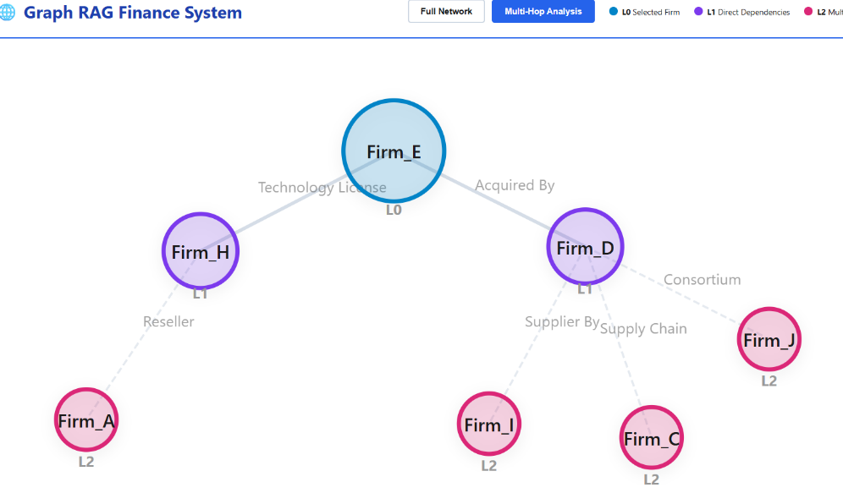
Figure 6. Graph RAG multi-hop reasoning visualization highlighting relational paths and dependencies across interconnected entities.

The Graph RAG system introduces many features to KG-RAG, including the ability to perform explicit multi-hop reasoning by graph traversal. Entities are separated into levels (L0, L1, L2, L3) according to their distance from the node being searched, which enables the system to capture the dependencies, both direct and indirect. As in the example of Fig. 6, the system represents the data as a layered graph format which draws highlighted multi-level relationships between and across entities.
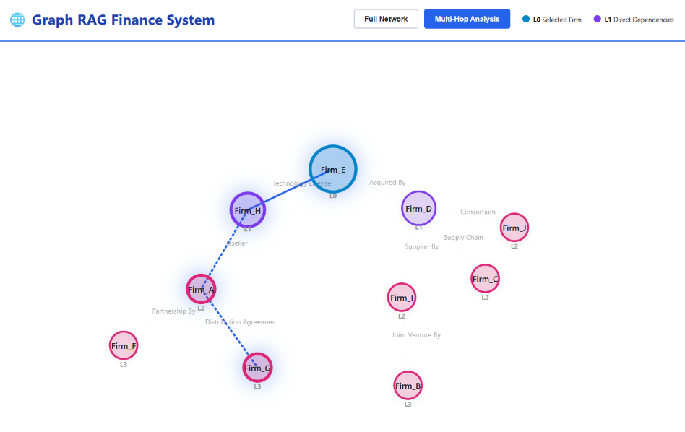

Figure 7. Extracted reasoning paths in Graph RAG demonstrating explicit multi-hop traversal across entities.

Furthermore, Fig. 7 shows the inclusion of explicit reasoning paths, connecting multi-hop connections into visual representations and partiality structures that follow multi-hop connections. This allows the system to generate more interpretable and properly logical outputs since it associates response to identifiable relational paths.

7. Results

The findings of the experiments suggest that there is a visible difference in performance across the three different methods. Vanilla RAG is good at operating with direct questions but is poor in the capability of handling relational and multi-entity queries due to the absence of context with the structure. KG-RAG is better in terms of retrieval quality, as this incorporates entity relationships thus leading to better contextual grounding of retrieval and more relevant response to queries.
The most notable increase in the capacity to cope with complex queries, such as indirect dependencies, and varied-hop reasoning, is indicated by Graph RAG. Being able to explicitly manipulate graph structures and describe ways of reasoning, which enhances the production of coherent and interpretable outputs. Moreover, the hierarchical levels of nodes and pathways of reasoning are visualized, so it is clear how answers are derived. The findings indicate that Graph RAG provides more robust and interpretable frameworks of approaching reasoning type tasks than traditional RAG and KG-RAG systems do.

Table 3. Comparative evaluation of Vanilla RAG, KG-RAG, and Graph RAG highlighting differences in knowledge sources, grounding mechanisms, reasoning capabilities, interpretability, and task suitability.

Dimension | Vanilla RAG | KG-RAG | Graph RAG
Knowledge Source | Unstructured documents + embeddings | Entities + relationships (Knowledge Graph) | Structured subgraphs + relational paths
Grounding Mechanism | Text-based grounding | Entity-level grounding | Path-based structural grounding
Reasoning Capability | Implicit, limited to single hop | Semi-structured, entity-aware reasoning | Explicit multi-hop reasoning via graph traversal
Interpretability | Moderate (documents visible) | High (entity relationships visible) | Very high (reasoning paths traceable)
Hallucination Reduction | Improved over parametric models | Further reduced via structured context | Strong reduction in relational queries
Best-Suited Tasks | Fact lookup, simple QA | Context-aware queries, domain-specific tasks | Multi-hop reasoning, dependency analysis

8. Application Areas of Knowledge Graph Enhanced Retrieval-Augmented Generation

Knowledge Graph enhanced Retrieval-Augmented Generation (KG-RAG) systems have been used successfully in many varied fields from scientific research, manufacturing, medicine, to enterprise knowledge management use cases where the presence of structured relationships allows improved multi-hop reasoning, In healthcare, there are graph-based retrieval for better faithfulness and safer decision making leveraging on rich biomedical relationships, and enterprise applications which benefits by explainable and traceable retrieval based on organizational knowledge structures. In these areas, KG-RAG is flexible as an architectural paradigm with regard to altering retrieval strategy and representation of graphs yet maintaining a similar paradigm.

9. Evaluative Methodologies and Standards

The assessment of KG-RAG systems is a rather unique challenge due to a combination of structured retrieval, ability to reason and ability to generate synthesis, which requires multi-dimensional evaluation schemes which are not based on traditional evaluation measures, but based on measuring the relevance of retrieval, the correctness of reasoning and the fidelity of grounding. Intrinsic evaluation methods focus on the evaluation of the quality of retrieved subgraphs, relations and reasoning paths based on graph-specific evaluation metrics like structural coherence and relation relevance, which play an important role in multi-hop reasoning tasks. However, These methods, have the limitation of low level of annotated graph benchmark and the inability to construct gold standard subgraphs.

10. Challenges and Research Questions

KG-RAG systems face several serious challenges that include the quality and reliability of the underlying knowledge graphs, in which noise, missing relations, and structural inconsistency may spread as a result of retrieval and reasoning mechanisms, leading to poor performance. Moreover, the temporal dynamics and knowledge evolution are not explored that well, as time-evolving graphs need to be up-to-date and consistent over time, whereas corpora do not. The lack of standardized evaluation frameworks limits generalizability across studies, making it difficult to compare results and highlighting the need for more robust and reproducible KG-RAG system designs.

11. Future Directions

Future KG-RAG research directions will be more aimed at achieving more profound integration of the symbolic knowledge and neural learning, preserving interpretability and constraint enforcing strengths of knowledge graphs with the neural models of their scalable and robust benefits. The other method is to create continuous learning systems and dynamic knowledge graphs which can evolve through time, but without worsening retrieval and generation performance. Moreover, there is also the growing interest in autonomous and agent-oriented KG-RAG systems, iterative and adaptive query and reasoning refines the queries and reasoning based on interaction with graph. Besides this, at the moment there are no general structures that restrict the possibility to make the comparison between one KG-RAG system and another in a fair and holistic way and thus the standardization is necessary to move to more principled design and assessment of the KG-RAG systems.

12 Conclusion

Knowledge Graph-Enhanced Retrieval-Augmented Generation is an important advancement in basing large language models on structured and understandable knowledge. Inspired by the architecture of the vanilla RAG, KG-RAG and Graph RAG add structure to the retrieval process, allowing more contextual and semantically rich generation.

This paper provided an experimental comparison of vanilla RAG, KG-RAG and Graph RAG, their architectural features, retrieval strategies, and reasoning abilities. The findings show that there is a definite distinction across these paradigms based on various factors. Vanilla RAG is useful in simple textual retrieval procedures when unstructured access to documents is not crucial. KG-RAG takes this ability further by adding explicit nodes, edges, and relationships, which allows a more organized way of knowledge representation and a better comprehension of relationships.

Graph RAG is the most promising among the strategies, especially when it comes to tasks that involve multi-hop reasoning, exploration of dependency paths, and more in-depth relational analysis. Using graph traversal paradigms, Graph RAG allows navigating more effectively among interconnected knowledge, which leads to improved reasoning. Such a systematic traversal has not only the benefit of enhancing the quality of answers, but also leads to increased interpretability and explainability since the reasoning process can be followed through clear paths in the graph.

Moreover, Graph RAG has been shown to be more effective in the identification of more complex dependencies and produce responses that are well-grounded in the underlying knowledge structures. Its flexibility in allowing traversal mechanisms to combine with structured representation makes it one of the most effective methods of dealing with knowledge-intensive tasks.

Overall, the findings of this study highlight that while vanilla RAG and KG-RAG serve important roles in the evolution of retrieval-augmented systems, Graph RAG emerges as a particularly powerful and interpretable paradigm, offering superior performance in reasoning-driven scenarios. This supports its possibility as a primary direction in future advancements in knowledge-grounded generative AI systems.

REFERENCES
- Bahr, L., Wehner, C., Wewerka, J., Bittencourt, J., Schmid, U., Daub, R.: Knowledge graph enhanced retrieval-augmented generation for failure mode and effects analysis. Journal of Industrial Information Integration 45, 100807 (2025)
- Cao, Y., Liu, Y., Zhang, Q., Wang, X., Huang, X.: LEGO-GraphRAG: Modular graph-guided retrieval augmented generation for document comprehension. arXiv preprint arXiv:2411.05844 (2024)
- Chen, C.H.: KAQG: A knowledge-graph-enhanced RAG for difficulty-controlled question generation. SSRN Electronic Journal (2025)
- Gao, Z., Cao, Y., Wang, H., Ke, A., Feng, Y., Xie, X., Zhou, S.K.: FRAG: A flexible modular framework for retrieval-augmented generation based on knowledge graphs. arXiv preprint arXiv:2501.09957 (2025)
- Han, H., Ma, L., Shomer, H., Wang, Y., Lei, Y., Guo, K., Tang, J.: RAG vs. GraphRAG: A systematic evaluation and key insights. arXiv preprint arXiv:2502.11371 (2025)
- Han, H., Wang, Y., Shomer, H., Guo, K., Lei, Y.: Graph retrieval-augmented generation: A survey. arXiv preprint arXiv:2408.08921 (2024)
- Han, H., Wang, Y., Shomer, H., Guo, K., Lei, Y., Long, B., Aggarwal, C.C., Tang, J.: Retrieval-augmented generation with graphs (GraphRAG). arXiv preprint arXiv:2501.00309 (2025)
- Knollmeyer, S., Shrestha, A., Wheeler, D.: Document GraphRAG: Graph-based retrieval-augmented generation for long documents. Electronics 14(11), 2102 (2024)
- Wang, Z., Kong, H., Ying, J., Ouyang, W., Dong, N.: ROGRAG: A robustly optimized GraphRAG framework. arXiv preprint (2025)
- Lewis, P., Perez, E., Piktus, A., Petroni, F., Karpukhin, V., Goyal, N., Küttler, H., Lewis, M., Yih, W.-t., Rocktäschel, T., Riedel, S., Kiela, D.: Retrieval-augmented generation for knowledge-intensive NLP tasks. In: Advances in Neural Information Processing Systems (NeurIPS), vol. 33, pp. 9459–9474 (2020)
- Xu, Z., Cruz, M.J., Guevara, M., Wang, T., Deshpande, M., Wang, X., Li, Z.: Retrieval-augmented generation with knowledge graphs for customer service question answering. arXiv preprint (2024)
- Liu, H., Wang, S., Li, J.: Knowledge graph retrieval-augmented generation via graph neural network-guided prompting. In: OpenReview (2025)
- Meister, F., Khanal, P., Trauner, L., Daub, R.: Retrieval-augmented generation using knowledge graphs for manufacturing problem-solving. In: Proceedings of the IEEE 21st International Conference on Automation Science and Engineering (CASE 2025), pp. 881–886 (2025)
- Wang, S., Fan, W., Feng, Y., Lin, S., Ma, X., Wang, S., Yin, D.: Knowledge graph retrieval-augmented generation for large language model-based recommendation. In: Proceedings of the 63rd Annual Meeting of the Association for Computational Linguistics (ACL 2025), pp. 27152–27168 (2025)
- Wang, S., Yang, H., Liu, W.: Research on the construction and application of retrieval enhanced generation (RAG) model based on knowledge graph. Scientific Reports 15, 21222 (2025)
- Xiong, Y., et al.: When knowledge graph meets retrieval augmented generation for wireless networks: A tutorial and case study. IEEE Wireless Communications (2025)
- Yu, J., Liu, Y., Gu, J., Torr, P., Zhou, D.: Can knowledge-graph-based retrieval augmented generation really retrieve what you need? arXiv preprint arXiv:2510.16582 (2025)
- Zhang, H., Si, J., Yan, G., Qi, B., Cai, P., Mao, S., Shi, B.: RAKG: Document-level retrieval augmented knowledge graph construction. arXiv preprint arXiv:2504.09823 (2025)
- Zhang, Q., Chen, S., Bei, Y., Yuan, Z., Zhou, H., Hong, Z., Huang, X.: A survey of graph retrieval-augmented generation for customized large language models. arXiv preprint arXiv:2501.13958 (2025)
- Zheng, Y., Yang, D., Li, J., Shang, L., Chen, L., Xu, J., Luan, S.: Less is more: Denoising knowledge graphs for retrieval augmented generation. arXiv preprint arXiv:2510.14271 (2025).

